Practice Problems 4 Topic: Linked Lists ID:2023000000033

1. Write a code to create a linked list containing five nodes and display the values.

Nodes are: p = 7 q = 5 r = 13 s = 10 t = 11

Solution 1:

#include<stdio.h>

#include<stdlib.h>

struct node{

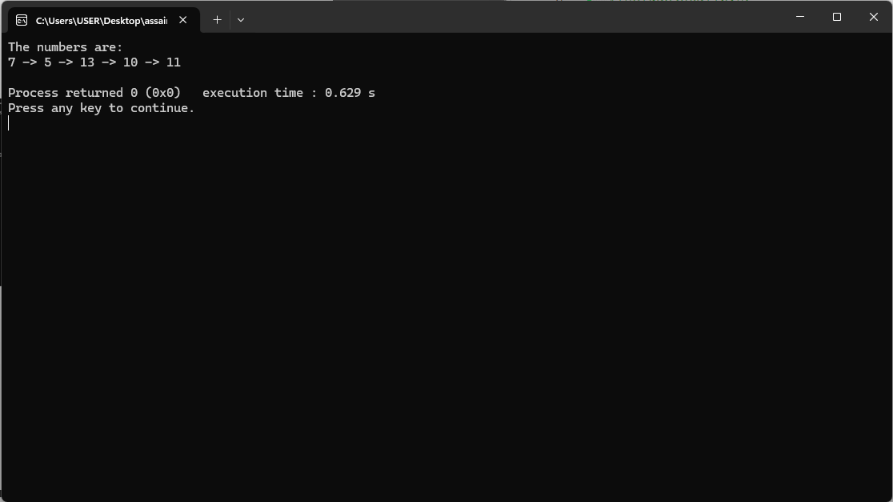int data;

struct node\* next;

};

int main() {

struct node\* head =NULL;

struct node\* p =NULL;

struct node\* q =NULL;

struct node\* r =NULL;

struct node\* s =NULL;

struct node\* t =NULL;

p=malloc(sizeof(struct node));

q=malloc(sizeof(struct node));

r=malloc(sizeof(struct node));

s=malloc(sizeof(struct node));

t=malloc(sizeof(struct node));

p->data=7;

q->data=5;

r->data=13;

s->data=10;

t->data=11;

head=p;

p->next=q;

q->next=r;

r->next=s;

s->next=t;

t->next=NULL;

struct node\* temp=head;

printf("The numbers are:\n");

while(temp!=NULL){

printf("%d -> ",temp->data);

if(temp->next->next==NULL){

temp=temp->next;

printf("%d\n",temp->data);

}

temp=temp->next;

}

return 0;

}

2. Now modify the previous code in such a way so that user can input the values in the

given nodes p,q,r,s,t by using loop.

Solution 2:

#include<stdio.h>

#include<stdlib.h>

struct node{

int data;

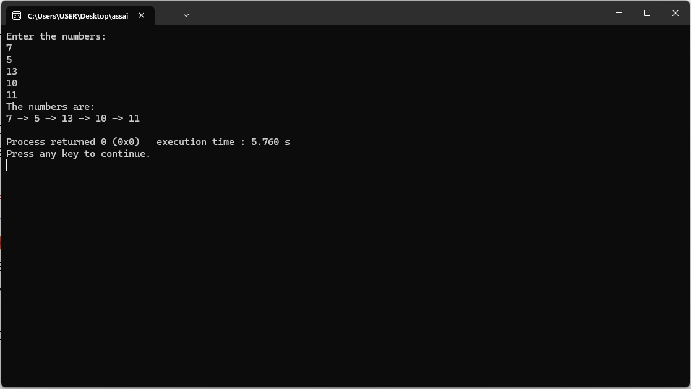struct node\* next;

};

int main() {

struct node\* head =NULL;

struct node\* p =NULL;

struct node\* q =NULL;

struct node\* r =NULL;

struct node\* s =NULL;

struct node\* t =NULL;

p=malloc(sizeof(struct node));

q=malloc(sizeof(struct node));

r=malloc(sizeof(struct node));

s=malloc(sizeof(struct node));

t=malloc(sizeof(struct node));

head=p;

p->next=q;

q->next=r;

r->next=s;

s->next=t;

t->next=NULL;

struct node\* current=head;

printf("Enter the numbers:\n");

while(current!=NULL)

{

scanf("%d",&current->data);

current=current->next;

}

struct node\* temp=head;

printf("The numbers are:\n");

while(temp!=NULL){

printf("%d -> ",temp->data);

if(temp->next->next==NULL){

temp=temp->next;

printf("%d\n",temp->data);

}

temp=temp->next;

}

return 0; }

3. Now update the same code in such a way so that user can define how many nodes

he/she wants to create then input the values in nodes.

Solution 3:

#include<stdio.h>

#include<stdlib.h>

struct node{

int data;

struct node\* next;

};

int main()

{

printf("Enter the number of values:\n");

int n;

scanf("%d",&n);

struct node\* head =NULL;

struct node\* tmp =NULL;

struct node\* newnode =NULL;

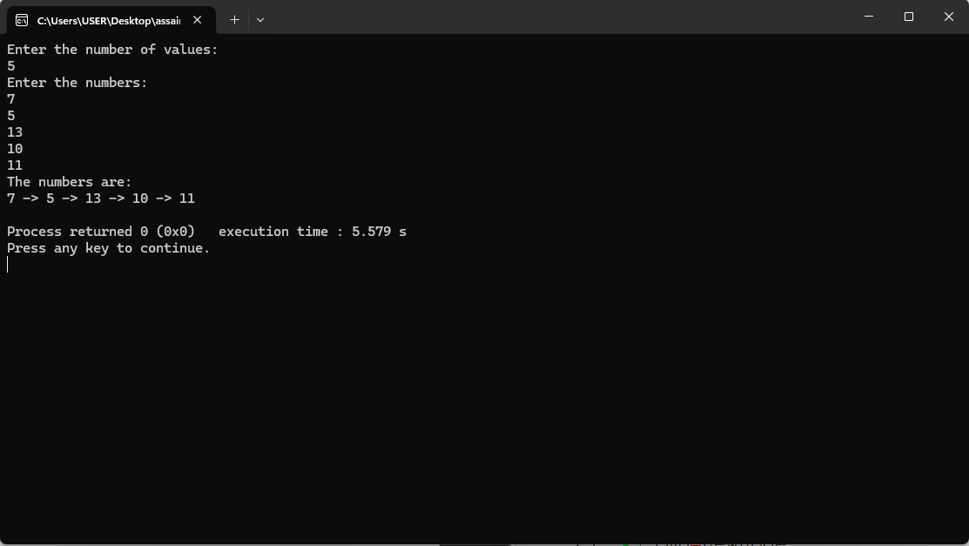head=NULL;

printf("Enter the numbers:\n");

for(int i=0;i<=n;i++){

if(i==n){

tmp->next=NULL;

break;

}

newnode=malloc(sizeof(struct node));

scanf("%d",&newnode->data);

if(head==NULL){

tmp=newnode;

head=tmp;

}else{

tmp->next=newnode;

tmp=newnode;

}

}

struct node\* temp=head;

printf("The numbers are:\n");

while(temp!=NULL){

printf("%d -> ",temp->data);

if(temp->next->next==NULL){

temp=temp->next;

printf("%d\n",temp->data);

}

temp=temp->next;

} return 0; }